Tạo project:
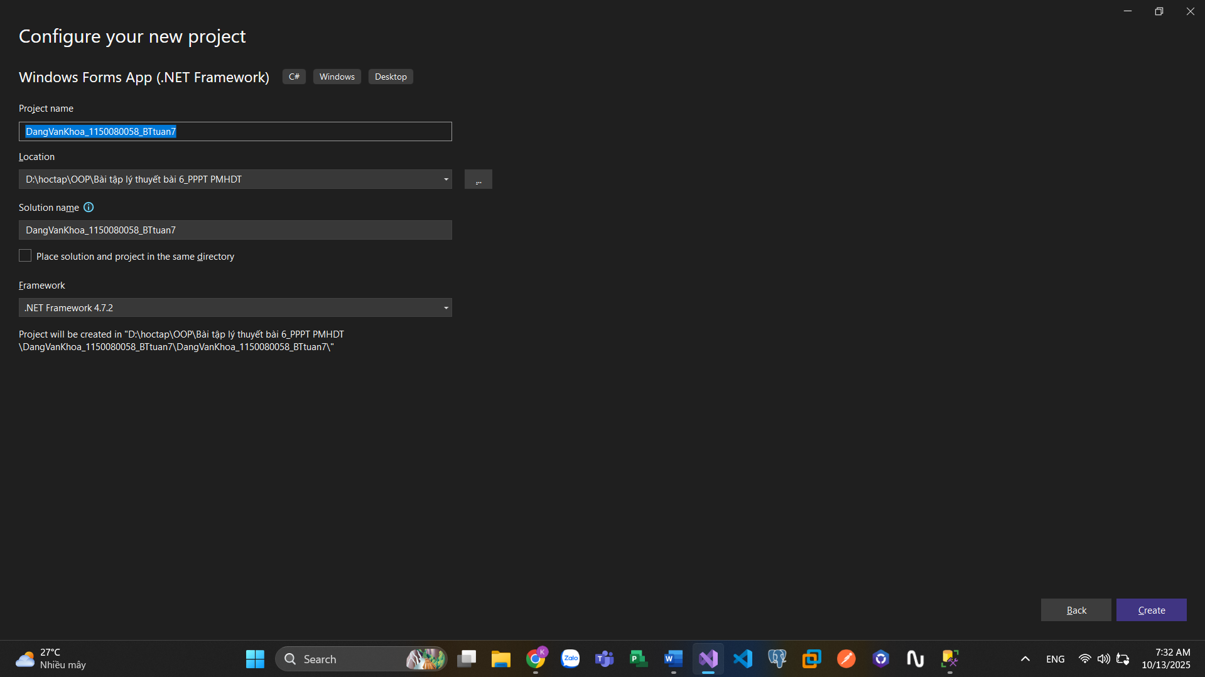
Chuột phải vào project chọn Add > New Item.
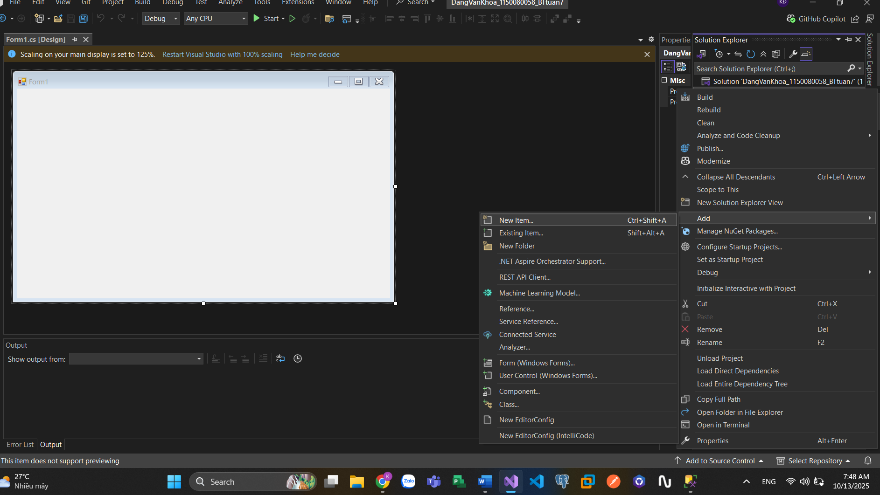
Trong danh sách các template, cuộn xuống và chọn Service-based Database.
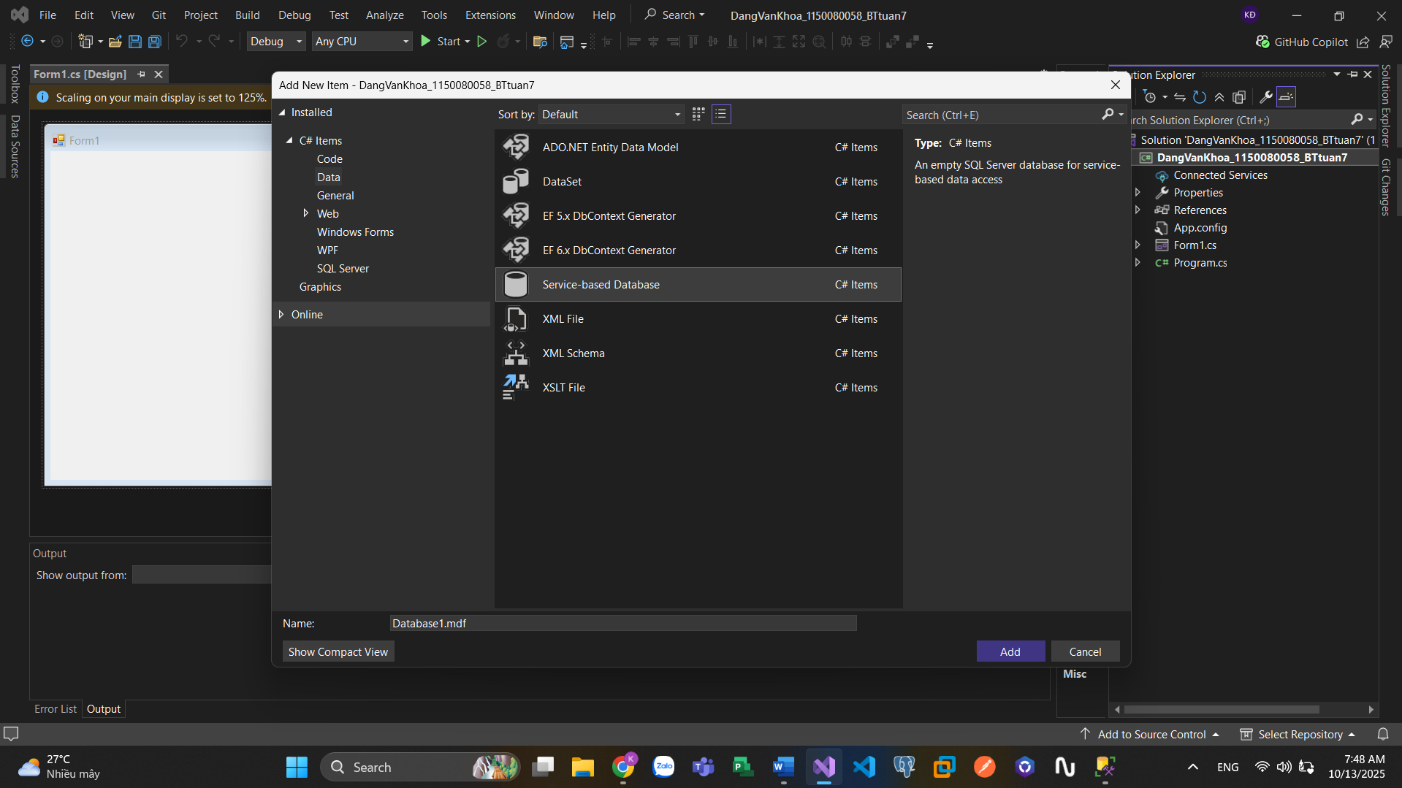
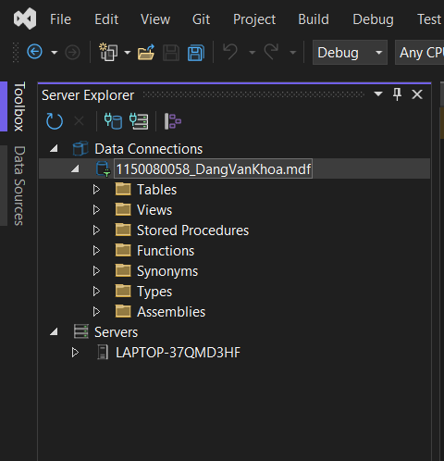
Tạo database:
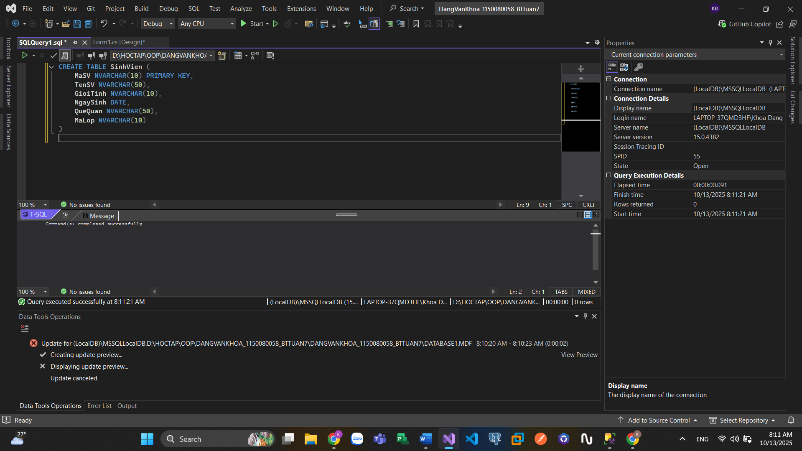
Thêm sinh viên:
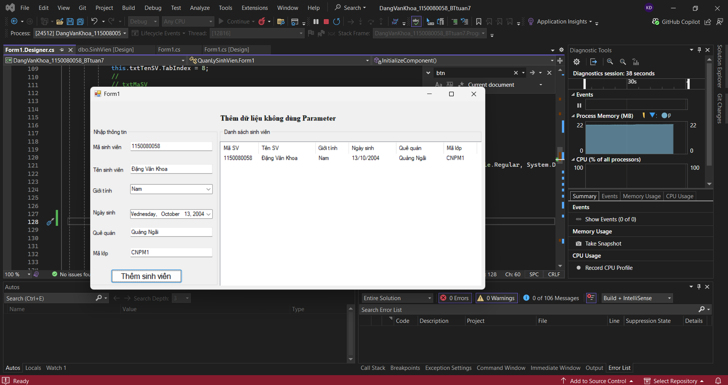

Code:
Form.cs
using System;
using System.Data;
using System.Data.SqlClient;
using System.Windows.Forms;

namespace QuanLySinhVien
{
public partial class Form1 : Form
{
// Chuỗi kết nối đến SQL Server
string strCon = @"Data Source=(LocalDB)\MSSQLLocalDB;
AttachDbFilename=|DataDirectory|\Database1.mdf;
Integrated Security=True";

SqlConnection sqlCon = null;

public Form1()
{
InitializeComponent();
}

private void groupBox1_Enter(object sender, EventArgs e)
{
}
// Mở kết nối
private void MoKetNoi()
{
if (sqlCon == null)
sqlCon = new SqlConnection(strCon);

if (sqlCon.State == ConnectionState.Closed)
sqlCon.Open();
}

// Đóng kết nối
private void DongKetNoi()
{
if (sqlCon != null && sqlCon.State == ConnectionState.Open)
sqlCon.Close();
}

// Hiển thị danh sách sinh viên
private void HienThiDanhSach()
{
MoKetNoi();

SqlCommand sqlCmd = new SqlCommand("SELECT * FROM SinhVien", sqlCon);
SqlDataReader reader = sqlCmd.ExecuteReader();

lsvDanhSachSV.Items.Clear();

while (reader.Read())
{
string maSv = reader.GetString(0);
string tenSV = reader.GetString(1);
string gioiTinh = reader.GetString(2);
string ngaySinh = reader.GetDateTime(3).ToString("dd/MM/yyyy");
string queQuan = reader.GetString(4);
string maLop = reader.GetString(5);

ListViewItem lvi = new ListViewItem(maSv);
lvi.SubItems.Add(tenSV);
lvi.SubItems.Add(gioiTinh);
lvi.SubItems.Add(ngaySinh);
lvi.SubItems.Add(queQuan);
lvi.SubItems.Add(maLop);

lsvDanhSachSV.Items.Add(lvi);
}

reader.Close();
DongKetNoi();
}

// Thêm sinh viên
private void btnThemSinhVien_Click(object sender, EventArgs e)
{
try
{
MoKetNoi();
string maSV = txtMaSV.Text.Trim();
string tenSV = txtTenSV.Text.Trim();
string gioiTinh = cbGioiTinh.Text;
DateTime ngaySinh = dtpNgaySinh.Value; // Lấy kiểu DateTime
string queQuan = txtQueQuan.Text.Trim();
string maLop = txtMaLop.Text.Trim();

// CÂU LỆNH SQL AN TOÀN SỬ DỤNG THAM SỐ
string sql = "INSERT INTO SinhVien VALUES (@MaSV, @TenSV, @GioiTinh, @NgaySinh, @QueQuan, @MaLop)";

SqlCommand cmd = new SqlCommand(sql, sqlCon);

// Thêm các tham số và giá trị tương ứng
cmd.Parameters.AddWithValue("@MaSV", maSV);
cmd.Parameters.AddWithValue("@TenSV", tenSV);
cmd.Parameters.AddWithValue("@GioiTinh", gioiTinh);
cmd.Parameters.AddWithValue("@NgaySinh", ngaySinh);
cmd.Parameters.AddWithValue("@QueQuan", queQuan);
cmd.Parameters.AddWithValue("@MaLop", maLop);

int kq = cmd.ExecuteNonQuery();

if (kq > 0)
{
MessageBox.Show("Thêm sinh viên thành công!");
HienThiDanhSach();
}
}
catch (Exception ex)
{
MessageBox.Show("Thêm dữ liệu bị lỗi: " + ex.Message);
}
finally
{
DongKetNoi();
}
}
private void Form1_Load(object sender, EventArgs e)
{
cbGioiTinh.Items.Add("Nam");
cbGioiTinh.Items.Add("Nữ");
lsvDanhSachSV.View = View.Details;
lsvDanhSachSV.FullRowSelect = true;

lsvDanhSachSV.Columns.Add("Mã SV", 80);
lsvDanhSachSV.Columns.Add("Tên SV", 120);
lsvDanhSachSV.Columns.Add("Giới tính", 70);
lsvDanhSachSV.Columns.Add("Ngày sinh", 100);
lsvDanhSachSV.Columns.Add("Quê quán", 100);
lsvDanhSachSV.Columns.Add("Mã lớp", 70);

HienThiDanhSach();
}

private void txtMaSV_TextChanged(object sender, EventArgs e)
{

}
}
}
Form1.Designer
namespace QuanLySinhVien
{
partial class Form1
{
/// <summary>
/// Required designer variable.
/// </summary>
private System.ComponentModel.IContainer components = null;

/// <summary>
/// Clean up any resources being used.
/// </summary>
/// <param name="disposing">true if managed resources should be disposed; otherwise, false.</param>
protected override void Dispose(bool disposing)
{
if (disposing && (components != null))
{
components.Dispose();
}
base.Dispose(disposing);
}

#region Windows Form Designer generated code

/// <summary>
/// Required method for Designer support - do not modify
/// the contents of this method with the code editor.
/// </summary>
private void InitializeComponent()
{
this.groupBox1 = new System.Windows.Forms.GroupBox();
this.cbGioiTinh = new System.Windows.Forms.ComboBox();
this.dtpNgaySinh = new System.Windows.Forms.DateTimePicker();
this.txtMaLop = new System.Windows.Forms.TextBox();
this.txtQueQuan = new System.Windows.Forms.TextBox();
this.txtTenSV = new System.Windows.Forms.TextBox();
this.txtMaSV = new System.Windows.Forms.TextBox();
this.btnThemSinhVien = new System.Windows.Forms.Button();
this.label6 = new System.Windows.Forms.Label();
this.label5 = new System.Windows.Forms.Label();
this.label4 = new System.Windows.Forms.Label();
this.label3 = new System.Windows.Forms.Label();
this.label2 = new System.Windows.Forms.Label();
this.label1 = new System.Windows.Forms.Label();
this.groupBox2 = new System.Windows.Forms.GroupBox();
this.lsvDanhSachSV = new System.Windows.Forms.ListView();
this.label7 = new System.Windows.Forms.Label();
this.groupBox1.SuspendLayout();
this.groupBox2.SuspendLayout();
this.SuspendLayout();
//
// groupBox1
//
this.groupBox1.Controls.Add(this.cbGioiTinh);
this.groupBox1.Controls.Add(this.dtpNgaySinh);
this.groupBox1.Controls.Add(this.txtMaLop);
this.groupBox1.Controls.Add(this.txtQueQuan);
this.groupBox1.Controls.Add(this.txtTenSV);
this.groupBox1.Controls.Add(this.txtMaSV);
this.groupBox1.Controls.Add(this.btnThemSinhVien);
this.groupBox1.Controls.Add(this.label6);
this.groupBox1.Controls.Add(this.label5);
this.groupBox1.Controls.Add(this.label4);
this.groupBox1.Controls.Add(this.label3);
this.groupBox1.Controls.Add(this.label2);
this.groupBox1.Controls.Add(this.label1);
this.groupBox1.Location = new System.Drawing.Point(-2, 71);
this.groupBox1.Name = "groupBox1";
this.groupBox1.Size = new System.Drawing.Size(360, 407);
this.groupBox1.TabIndex = 0;
this.groupBox1.TabStop = false;
this.groupBox1.Text = "Nhập thông tin";
this.groupBox1.Enter += new System.EventHandler(this.groupBox1_Enter);
//
// cbGioiTinh
//
this.cbGioiTinh.FormattingEnabled = true;
this.cbGioiTinh.Location = new System.Drawing.Point(114, 144);
this.cbGioiTinh.Name = "cbGioiTinh";
this.cbGioiTinh.Size = new System.Drawing.Size(230, 24);
this.cbGioiTinh.TabIndex = 12;
//
// dtpNgaySinh
//
this.dtpNgaySinh.Location = new System.Drawing.Point(114, 209);
this.dtpNgaySinh.Name = "dtpNgaySinh";
this.dtpNgaySinh.Size = new System.Drawing.Size(230, 22);
this.dtpNgaySinh.TabIndex = 11;
//
// txtMaLop
//
this.txtMaLop.Location = new System.Drawing.Point(114, 309);
this.txtMaLop.Name = "txtMaLop";
this.txtMaLop.Size = new System.Drawing.Size(230, 22);
this.txtMaLop.TabIndex = 10;
//
// txtQueQuan
//
this.txtQueQuan.Location = new System.Drawing.Point(114, 256);
this.txtQueQuan.Name = "txtQueQuan";
this.txtQueQuan.Size = new System.Drawing.Size(230, 22);
this.txtQueQuan.TabIndex = 9;
//
// txtTenSV
//
this.txtTenSV.Location = new System.Drawing.Point(114, 92);
this.txtTenSV.Name = "txtTenSV";
this.txtTenSV.Size = new System.Drawing.Size(230, 22);
this.txtTenSV.TabIndex = 8;
//
// txtMaSV
//
this.txtMaSV.Location = new System.Drawing.Point(114, 33);
this.txtMaSV.Name = "txtMaSV";
this.txtMaSV.Size = new System.Drawing.Size(230, 22);
this.txtMaSV.TabIndex = 7;
this.txtMaSV.TextChanged += new System.EventHandler(this.txtMaSV_TextChanged);
//
// btnThemSinhVien
//
this.btnThemSinhVien.Font = new System.Drawing.Font("Microsoft Sans Serif", 12F, System.Drawing.FontStyle.Regular, System.Drawing.GraphicsUnit.Point, ((byte)(0)));
this.btnThemSinhVien.Location = new System.Drawing.Point(60, 364);
this.btnThemSinhVien.Name = "btnThemSinhVien";
this.btnThemSinhVien.Size = new System.Drawing.Size(201, 37);
this.btnThemSinhVien.TabIndex = 6;
this.btnThemSinhVien.Text = "Thêm sinh viên";
this.btnThemSinhVien.UseVisualStyleBackColor = true;
btnThemSinhVien.Click += btnThemSinhVien_Click;
//
// label6
//
this.label6.AutoSize = true;
this.label6.Location = new System.Drawing.Point(7, 315);
this.label6.Name = "label6";
this.label6.Size = new System.Drawing.Size(48, 16);
this.label6.TabIndex = 5;
this.label6.Text = "Mã lớp";
//
// label5
//
this.label5.AutoSize = true;
this.label5.Location = new System.Drawing.Point(7, 262);
this.label5.Name = "label5";
this.label5.Size = new System.Drawing.Size(65, 16);
this.label5.TabIndex = 4;
this.label5.Text = "Quê quán";
//
// label4
//
this.label4.AutoSize = true;
this.label4.Location = new System.Drawing.Point(7, 209);
this.label4.Name = "label4";
this.label4.Size = new System.Drawing.Size(67, 16);
this.label4.TabIndex = 3;
this.label4.Text = "Ngày sinh";
//
// label3
//
this.label3.AutoSize = true;
this.label3.Location = new System.Drawing.Point(7, 152);
this.label3.Name = "label3";
this.label3.Size = new System.Drawing.Size(54, 16);
this.label3.TabIndex = 2;
this.label3.Text = "Giới tính";
//
// label2
//
this.label2.AutoSize = true;
this.label2.Location = new System.Drawing.Point(7, 98);
this.label2.Name = "label2";
this.label2.Size = new System.Drawing.Size(86, 16);
this.label2.TabIndex = 1;
this.label2.Text = "Tên sinh viên";
//
// label1
//
this.label1.AutoSize = true;
this.label1.Location = new System.Drawing.Point(7, 39);
this.label1.Name = "label1";
this.label1.Size = new System.Drawing.Size(81, 16);
this.label1.TabIndex = 0;
this.label1.Text = "Mã sinh viên";
//
// groupBox2
//
this.groupBox2.Controls.Add(this.lsvDanhSachSV);
this.groupBox2.Location = new System.Drawing.Point(364, 71);
this.groupBox2.Name = "groupBox2";
this.groupBox2.Size = new System.Drawing.Size(735, 407);
this.groupBox2.TabIndex = 1;
this.groupBox2.TabStop = false;
this.groupBox2.Text = "Danh sách sinh viên";
//
// lsvDanhSachSV
//
this.lsvDanhSachSV.HideSelection = false;
this.lsvDanhSachSV.Location = new System.Drawing.Point(0, 33);
this.lsvDanhSachSV.Name = "lsvDanhSachSV";
this.lsvDanhSachSV.Size = new System.Drawing.Size(735, 374);
this.lsvDanhSachSV.TabIndex = 0;
this.lsvDanhSachSV.UseCompatibleStateImageBehavior = false;
//
// label7
//
this.label7.AutoSize = true;
this.label7.Font = new System.Drawing.Font("Times New Roman", 12F, System.Drawing.FontStyle.Bold, System.Drawing.GraphicsUnit.Point, ((byte)(0)));
this.label7.Location = new System.Drawing.Point(360, 32);
this.label7.Name = "label7";
this.label7.Size = new System.Drawing.Size(316, 23);
this.label7.TabIndex = 6;
this.label7.Text = "Thêm dữ liệu không dùng Parameter";
//
// Form1
//
this.AutoScaleDimensions = new System.Drawing.SizeF(8F, 16F);
this.AutoScaleMode = System.Windows.Forms.AutoScaleMode.Font;
this.ClientSize = new System.Drawing.Size(1111, 490);
this.Controls.Add(this.label7);
this.Controls.Add(this.groupBox2);
this.Controls.Add(this.groupBox1);
this.Name = "Form1";
this.Text = "Form1";
this.Load += new System.EventHandler(this.Form1_Load);
this.groupBox1.ResumeLayout(false);
this.groupBox1.PerformLayout();
this.groupBox2.ResumeLayout(false);
this.ResumeLayout(false);
this.PerformLayout();
}
#endregion
private System.Windows.Forms.GroupBox groupBox1;
private System.Windows.Forms.GroupBox groupBox2;
private System.Windows.Forms.Label label6;
private System.Windows.Forms.Label label5;
private System.Windows.Forms.Label label4;
private System.Windows.Forms.Label label3;
private System.Windows.Forms.Label label2;
private System.Windows.Forms.Label label1;
private System.Windows.Forms.Label label7;
private System.Windows.Forms.TextBox txtMaLop;
private System.Windows.Forms.TextBox txtQueQuan;
private System.Windows.Forms.TextBox txtTenSV;
private System.Windows.Forms.TextBox txtMaSV;
private System.Windows.Forms.Button btnThemSinhVien;
private System.Windows.Forms.ComboBox cbGioiTinh;
private System.Windows.Forms.DateTimePicker dtpNgaySinh;
private System.Windows.Forms.ListView lsvDanhSachSV;
}
}

